Interactive Quiz Application

Submitted By: Abhishek Paul Johnson, Vinola Fiona Rasquinha, Liya Babu  
Roll Number: 2462008, 2462170, 2462108  
College Email: [abhishek.paul@btech.christuniversity.in](mailto:abhishek.paul@btech.christuniversity.in) [vinola.fiona@btech.christuniversity.in](mailto:vinola.fiona@btech.christuniversity.in), [liya.babu@btech.christuniversity.in](mailto:liya.babu@btech.christuniversity.in)   
  
Course: UI/UX Design Fundamentals  
Instructor Name: Ms. Nagaveena  
Institution: Christ University

Date of Submission: 26/09/2025

**Abstract**

This project focuses on the design and development of an Interactive Quiz Application that enables users to attempt multiple-choice questions, receive instant feedback, and view their final score upon completion. The application is designed to be engaging, user-friendly, and responsive, making it suitable for both learning and self-assessment purposes. It leverages HTML5 for structure, Bootstrap for styling and responsive layouts, and JavaScript for interactivity, real-time score tracking, and dynamic content updates. Additionally, the app incorporates a countdown timer, ensuring that quizzes are time-bound and simulating a real examination environment.

**Objectives**

The objectives of the Quiz Application are:

1. To provide a platform where users can attempt quizzes interactively.
2. To display multiple-choice questions with selectable options.
3. To calculate and display the score at the end of the quiz.
4. To provide immediate feedback after each question.
5. To implement timer functionality for time-bound assessments.
6. To design a responsive and user-friendly interface that works across devices.

**Scope of the Project**

The scope of this project is to build a client-side quiz application for single users to test their knowledge on a given topic. The application includes displaying multiple-choice questions, real-time feedback, score calculation, and a countdown timer. It is designed using HTML5, CSS3 with Bootstrap, and JavaScript. The project scope is limited to client-side functionality and does not include features such as multi-user login, server-side database storage, or advanced analytics. This ensures that the application remains lightweight, educational, and suitable for demonstrating essential concepts of web development.

**Tools & Technologies Used**

|  |  |
| --- | --- |
| Tool/Technology | Purpose |
| HTML5 | Provides the structure and content of the quiz application (questions, options, and layout). |
| CSS3 + Bootstrap 5 | Used for styling, layout management, and ensuring responsiveness across devices. |
| JavaScript (ES6+) | Handles interactivity, question navigation, timer, feedback, and score calculation. |
| Local Storage (optional) | Can be used to store quiz progress or user attempts locally. |
| VS Code / Any Code Editor | Development and editing environment for writing and testing the code. |
| Chrome/Firefox Developer Tools | Debugging, testing, and ensuring cross-browser compatibility. |

**HTML Structure Overview**

The quiz application follows a structured HTML5 layout using semantic tags for clarity and maintainability. The key elements include:

* **<header>** – Displays the quiz title or application heading.
* **<main>** – Contains the core quiz interface including questions, options, and timer.
* **<section>** – Each question is wrapped in a section with multiple-choice options presented as radio buttons.
* **<div>** – Used for grouping options, feedback messages, and progress indicators.
* **<button>** – For submitting answers and navigating between questions (Next/Previous/Submit).
* **<footer>** – Displays the user’s final score and completion message.

**CSS Styling Strategy**

The quiz application’s styling uses Bootstrap 5 and a custom CSS file (style.css) to create a clean, responsive, and user-friendly design. The core strategy includes:

* **Mobile-First, Responsive Layout:** Built with Bootstrap’s grid system to ensure the quiz looks and works perfectly on any device, from phones to desktops.
* **Clear Typography and Colours:** Uses readable fonts and a consistent colour scheme to enhance focus and ensure text is easy to read.
* **Interactive User Feedback:** Buttons and answer choices have hover and active effects, providing immediate visual confirmation of user actions.
* **Visible Timers and Progress Bars:** Key elements like the timer are styled with distinct colours to keep the user informed and engaged.

**Key Features**

This project is an interactive quiz application that allows users to attempt multiple-choice questions. The app provides instant feedback after each question and includes a countdown timer for time-bound assessments. Upon completion, it calculates and displays the user's final score. The entire application features a responsive design, ensuring it works seamlessly across various devices

**Challenges Faced & Solutions**

The core challenges of this project were solved efficiently using the specified front-end toolkit. State management and dynamic content were handled client-side with JavaScript objects and jQuery's DOM manipulation. The Bootstrap grid was used to ensure a fully responsive layout across all devices , while interactive features like the countdown timer and instant feedback were implemented using JavaScript's.

**Outcome**

Interactive Quiz Application for self-assessment. It successfully delivers an interactive experience by displaying multiple-choice questions , providing a final score upon completion , and featuring a countdown timer. Built with JavaScript and Bootstrap, the final product is dynamic and fully responsive, ensuring a seamless user experience on any device.

**Future Enhancements**

Future enhancements would evolve the application from a client-side tool into a full-featured platform by integrating a backend and database to support expanded content, such as new quiz categories and question types. Implementing user accounts would enable more engaging features like performance-tracking dashboards, saved progress, and competitive leaderboards, creating a more personalized and robust user experience.

**Sample Code**

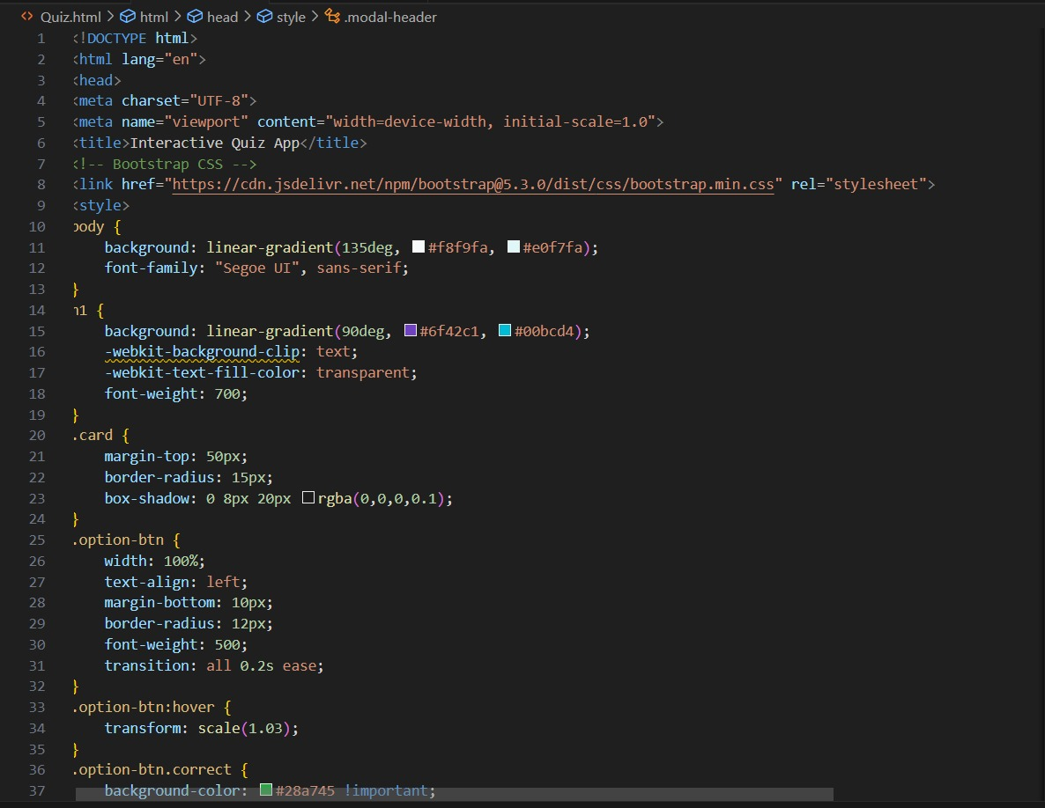

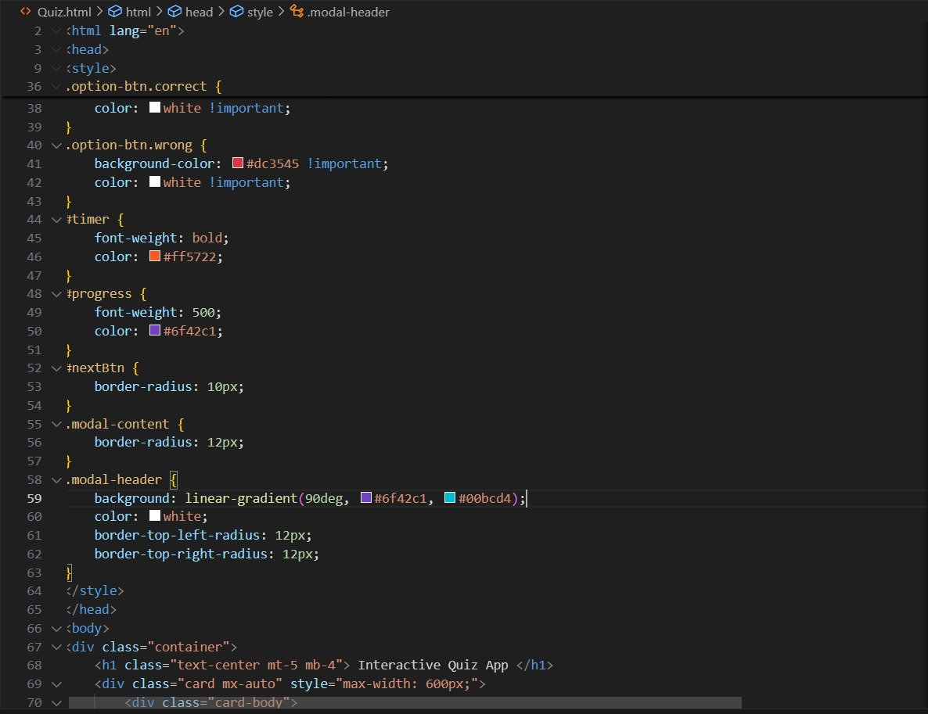

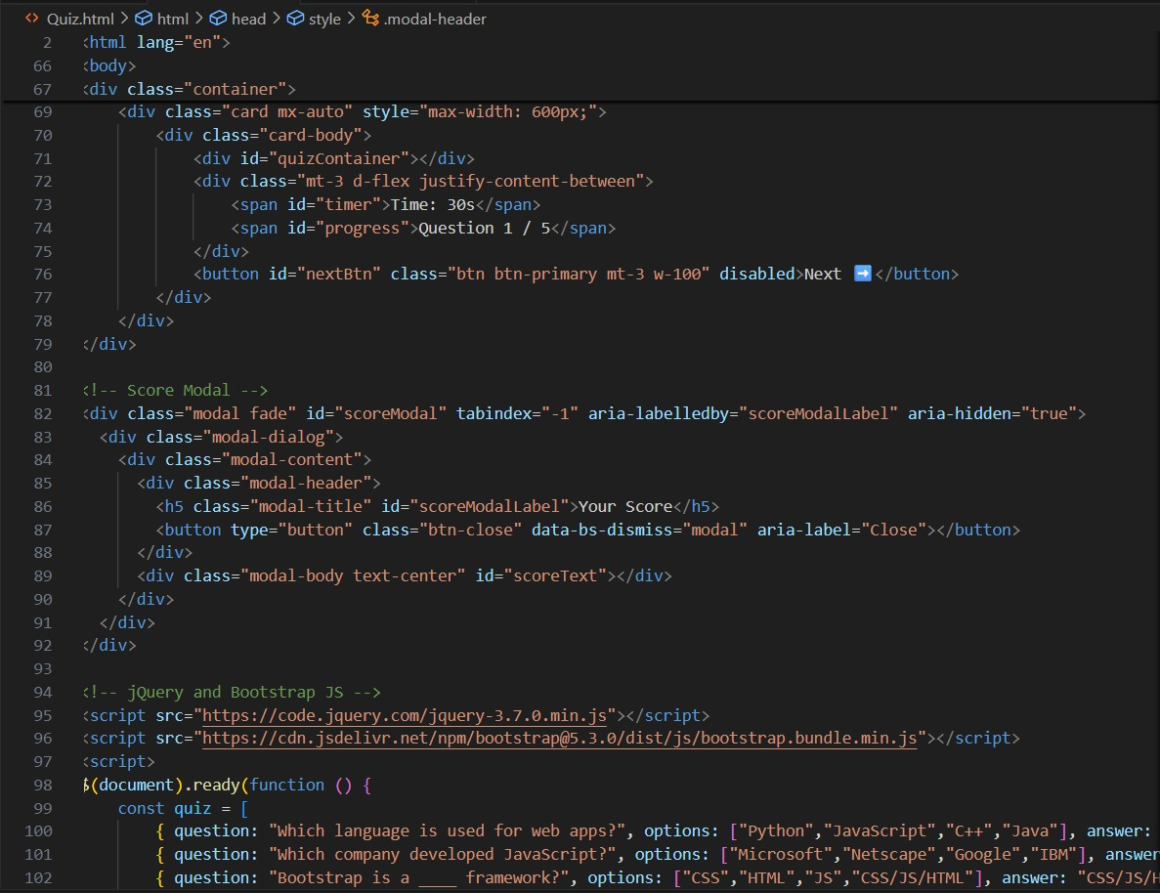

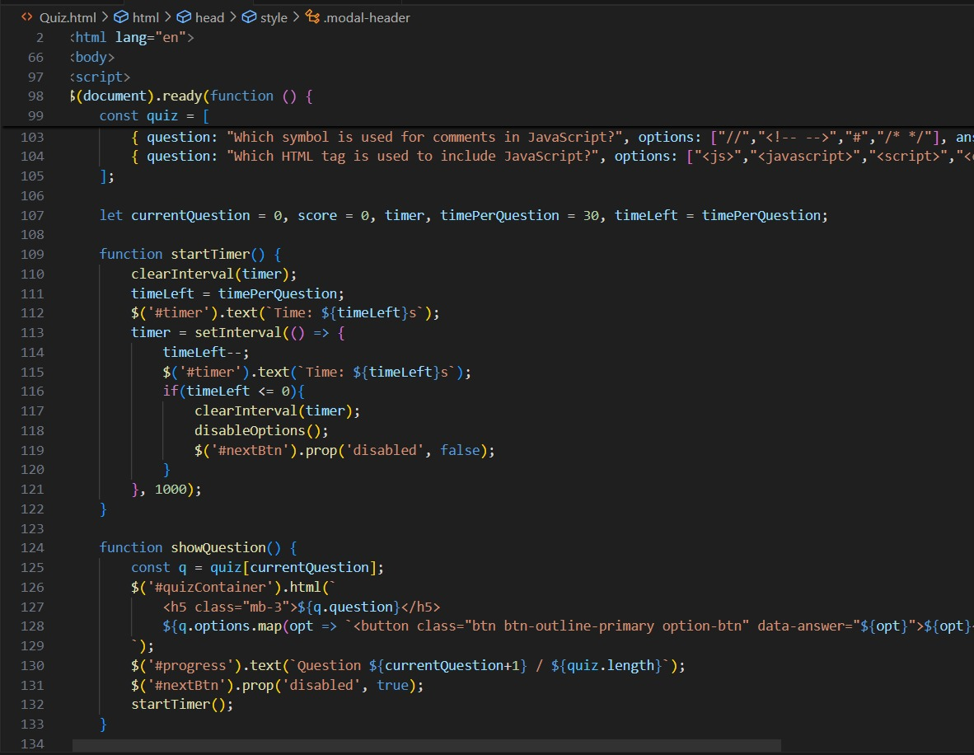

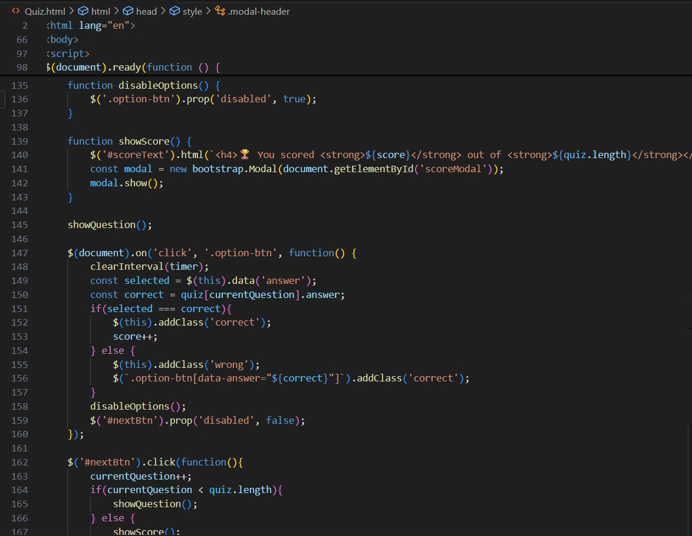

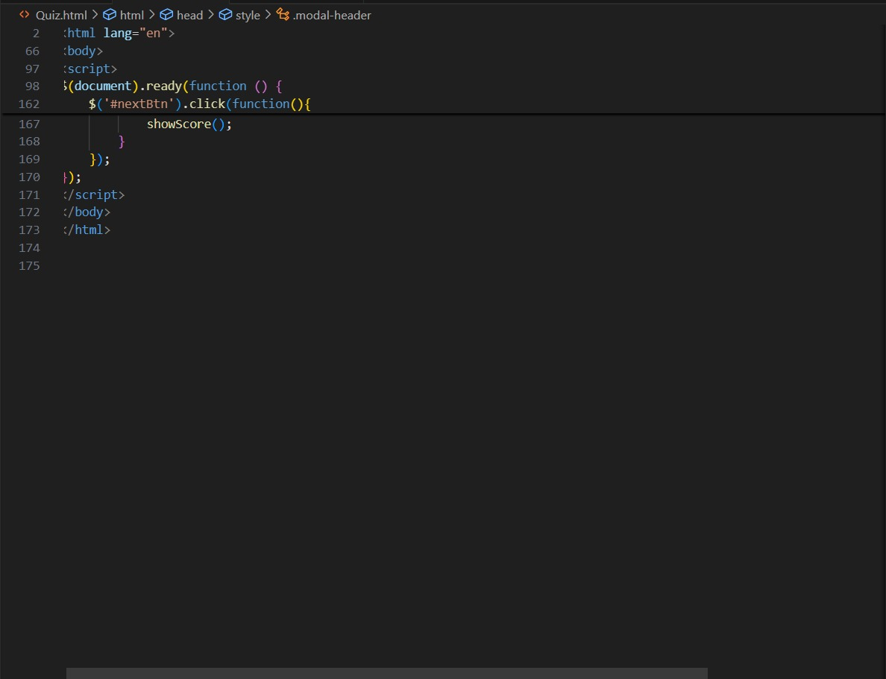

**Screenshot of Final Output**

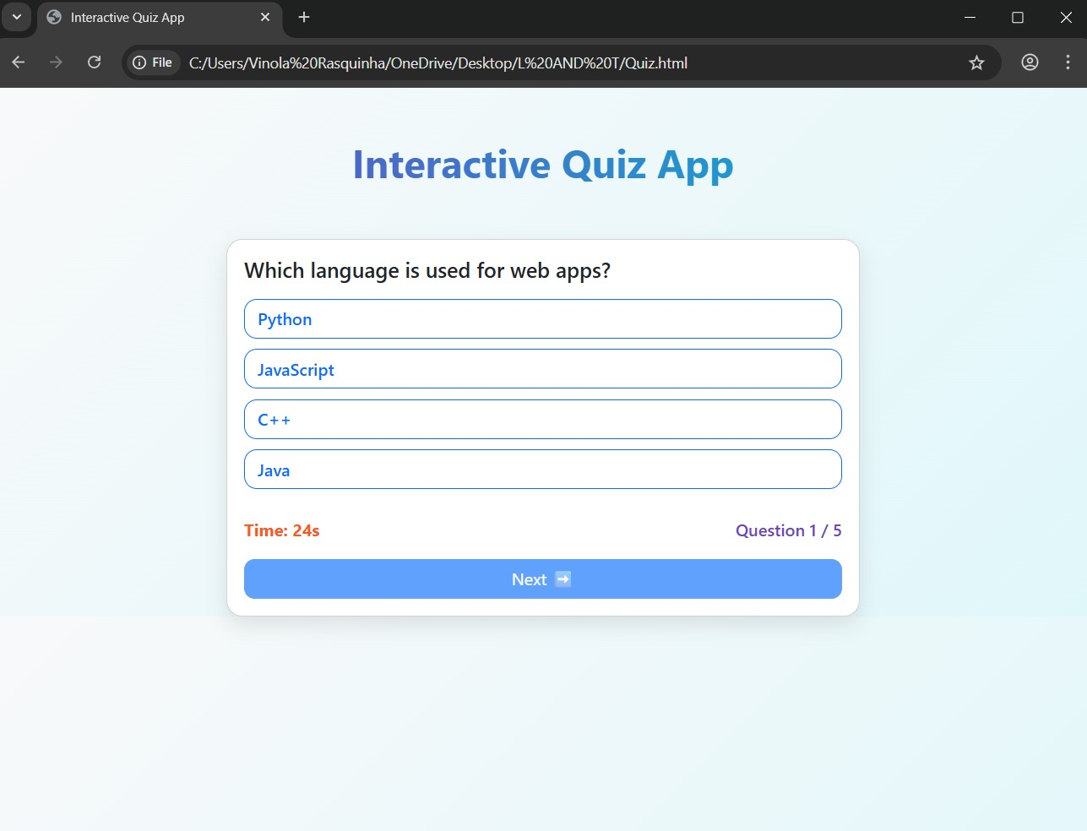

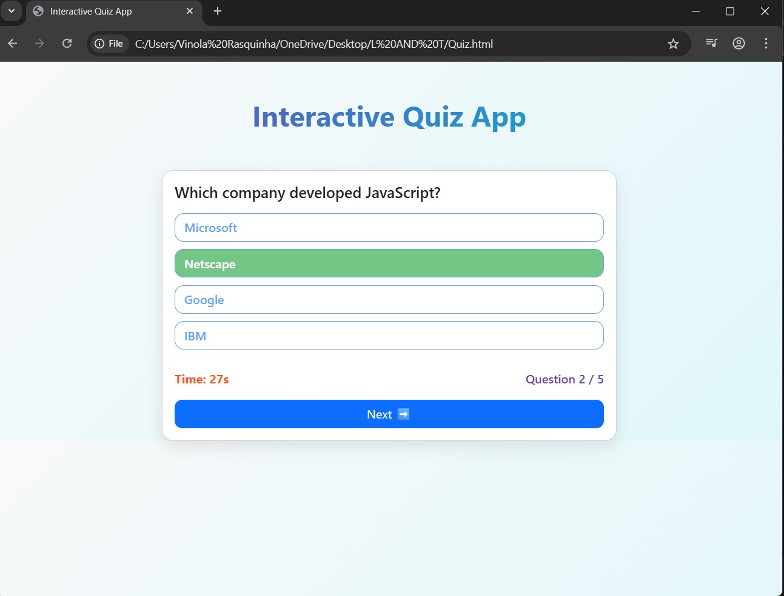

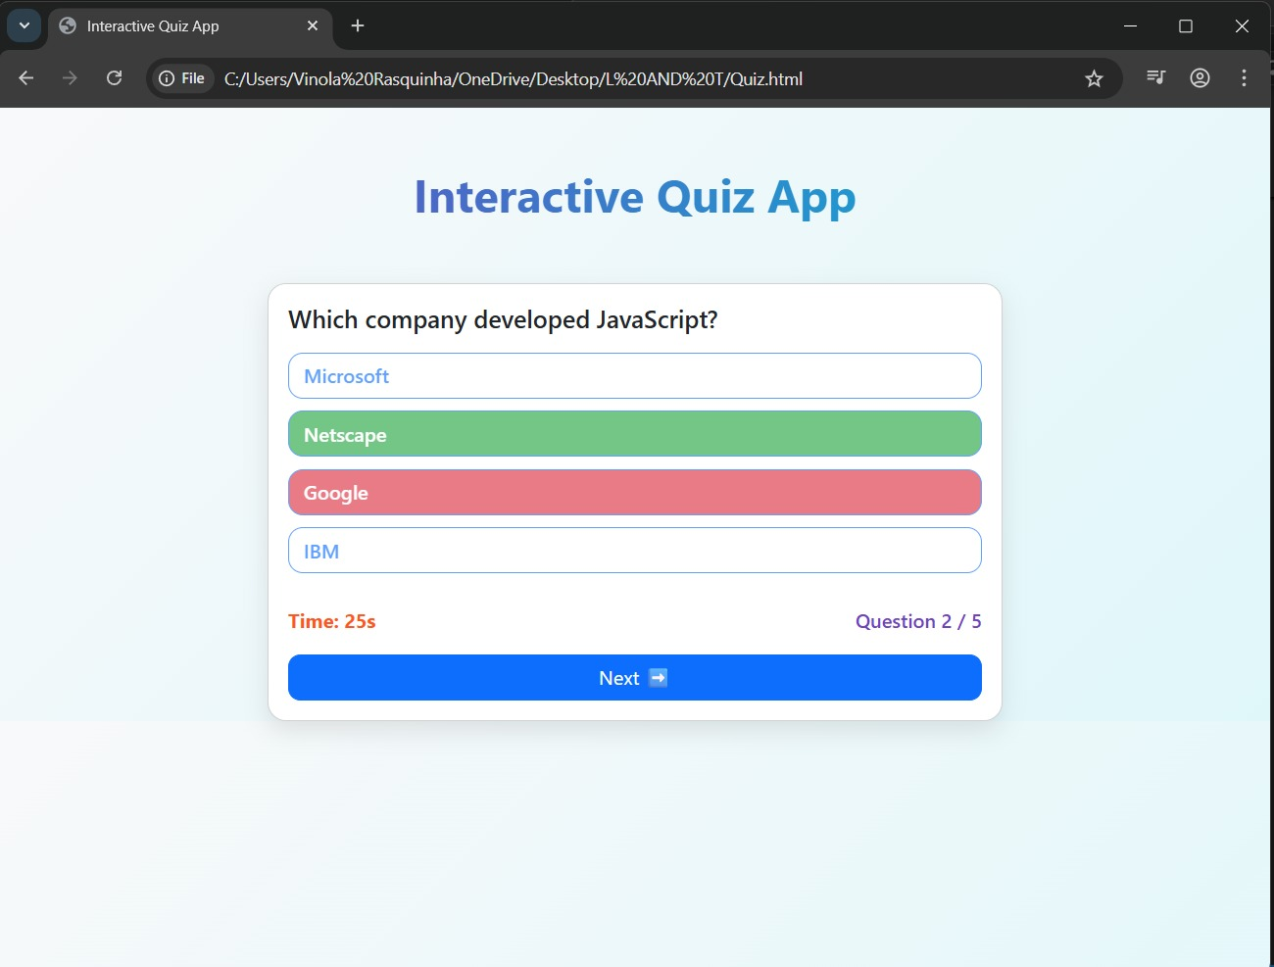

**Conclusion**

The Interactive Quiz Application project was successfully completed, delivering a responsive and user-friendly platform for self-assessment as intended. Key features such as dynamic questions, score calculation, and a countdown timer were effectively implemented using HTML, Bootstrap, and JavaScript. This client-side application serves as a practical demonstration of core front-end development skills, creating an engaging experience for users across all devices.

**References**

- L&T LMS: https://learn.lntedutech.com

Sensitivity: LNT Construction Internal Use